**Project for scheduling in smart grids**

Arun Srikantha, Divya Pathak, Harsha Panjwani, Varun Pillai

a Department of Chemical and Biological Engineering, Drexel University

b Department of Electrical and Computer Engineering, Drexel University

c Lebow Business School, Drexel University

**Case Study**

An optimal energy scheduling policy that considers the varying demands in a particular residential neighborhood as well as minimizes the total cost is necessary in the present situation where global energy resources are limited. In this proposal an optimal strategy to schedule the running time of home appliances in a neighborhood is proposed. The random variations in the start time and running time of home appliances and the cost of delay incurred in case an equipment is scheduled for a later time are taken into account. The optimization formulation for scheduling the appliances in a single household is discussed in detail and the results are presented. Various practical constraints that an actual EMC (Electricity Management Controller) encounters during scheduling of appliances are discussed and the procedures to take this into account in the optimization formulations are described.

The Problem is briefly discussed here .The Scheduling problem is divided into 4 parts.

1. First is a base case problem or a simplified scenario which involves optimally scheduling the run time of three appliances for a single household.

2. The next part involves including the capacity constraints in the scheduling problem which restricts the amount of power available for a given household per time slot.

3. The last part asks to extend the optimization formulation to a neighborhood which involves communication between EMC’s (Electric Management Company) of nearby homes to optimally schedule the run time of appliances.

4 Development of user interface to facilitate viewing the power consumption and appliance statistics from home user perspective and the utility company’s perspective.

The Data which is used for solving the case study is as follows

**Single Home**

1 No of Appliances considered = Dish washer, Clothes dryer , Water heater.

2 Number of Time Periods (T) = 24 hours.

3 Cost of Electricity in $ /KWH for each time period is given in appendix.

4 Cost of Delay CD , Cn1 for time period <= 6 = $ 0.1.

5. Cost of Delay CD, Cn2 for time period >= 6 = $ 2.5.

6. The Probability data of an equipment being on /off in a given time period is given in the appendix.

7. Power Consumption for each appliance is 1.8 KWH.

**Neighbourhood**

1No of Homes in Neighborhood = 15.

2No of Appliances in each home = 3.

3Number of Time periods (T) = 48 hours.

4Total No of Appliances considered = 45.

5Power Consumption for each appliance in a given time period is given in Appendix.

6 Electric Cost for each appliance in a given time period is given in Appendix.

7 Cost of Delay for each time period C_n1 is as given in appendix.

8 Cost of Delay for each time period C_n2 is as given in appendix.

9 Time Periods to be considered for C_n1 is as given in appendix.

**Executive Summary**

Electrical energy is not a directly storable commodity .Generation and consumption of electrical energy need to take place at the same time.

We purpose an Electricity Management Controller for Scheduling of Electrical appliances in a neighborhood. The EMC aims to reduce power consumption while supporting fluctuating demand in the network and in turn potentially benefit the utility company by making it easier to keep the grid stable, thus avoiding overload, brown outs, and blackouts.

Energy demands in a home or across multiple homes in a neighborhood are often flexible. Effective Scheduling of these flexible demands can help obtain reduced energy cost by shifting their loads to off peak hours when prices are reduced.

Taking into consideration the energy consumption costs and the costs due to delaying the operation of the requested appliance, our EMC determines an optimal time period in which the requested appliance should be turned on, while minimizing total expected cost.

Effective Scheduling of electrical appliances can save excessive power consumption from the Utility Company’s perspective and help the entire neighborhood by reducing the power consumption cost.

EMC,Electricity management controller was designed within a home to quickly and easily optimize the scheduling of appliances ,the Effective Scheduling of the EMC benefited a single home by giving an maximum effective saving of $ 1.16 /day by Scheduling appliances and shifting loads to off peak hours when prices are reduced. Apart from the cost savings achieved in single home ,a set of EMC’s in a multiple homes in a neighborhood achieved Maximum savings of $ /Day.

It helps the Utility Company to plan their energy capacities for this neighborhood comprising of 15 houses and thus helped them to plan their long term capacities for future avoiding blackouts and overloads.

The User interface is developed based on the rescheduling of appliances considering the delay cost gives a better visualization of the different jobs to the Electricity management controller and thus helps us achieve substantial savings in different scenarios.

**The pictorial view of the user interface developed in MATLAB .**

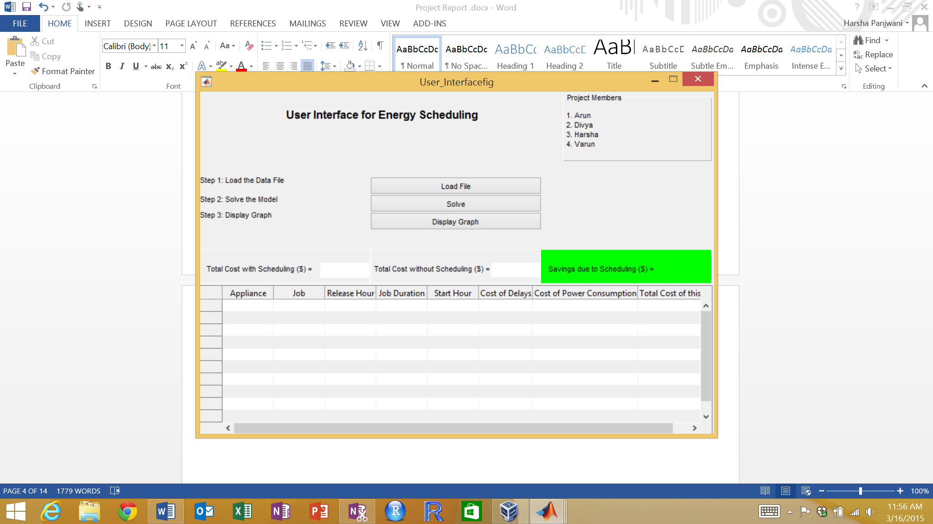

**Managerial Report**

We have considered a base case with a single home and 3 appliances which can be scheduled to obtain cost savings .The 3 appliances which we have considered are dish washer , water heater and clothes dryer for which it is possible for a customer to wait for the service and reschedule it in the later part of the day if the waiting cost associated with it is less than the cost of power consumption , but an electrical appliance like lamp which cannot be rescheduled at a later time is not included in the scope of this project.

The probabilities of an appliance being on to off in a specific time period and probabilities of an appliance being off to on in a specific time period are considered in this case and various scenarios of these appliances being on or off were simulated using Monte Carlo simulation techniques.

Monte Carlo Simulation techniques furnishes the decision maker with a range of possible outcomes and the probabilities they will occur for any choice of action.

Using Monte Carlo Simulation for this case of a single home provided us all the possible outcomes of our decisions and assessed the impact of risk, allowing for better decision making under uncertainty.

Not all scenarios were prospective, for some of the scenarios it was also observed that there were no tangible benefits of introducing delay, but in many scenarios scheduling definitely provided significant cost benefits from the user perspective.

The cost of Power for the single home in a neighborhood is less for a time period of 1-10th hours ,it increases in the peak hours, which is for time period 11-22nd hour and then again is low in the non-peak hours from 23-24th hour.

Given below are some of the graphical representations of the scenarios which gave us significant cost benefits in a period of 24 Hours by applying the delay cost in the peak hours when the cost of power is more, but we get the cost benefits only when we schedule the request of appliances which are close to the non-peak hours and the time period for which delay cost applied is small .We get optimum cost benefits when delay cost is applied for a request in 20th hour and we schedule the appliance in the 23rd hour with the delay cost for maximum of 3 time periods .

.

Case 1

|  |  |  |  |  |  |  |  |  |  |  |  |  |  |  |  |  |
| --- | --- | --- | --- | --- | --- | --- | --- | --- | --- | --- | --- | --- | --- | --- | --- | --- |
| |  |  |  | | --- | --- | --- | |  | **Cost (W/o Scheduling)** | **Cost (W Scheduling )** | | Dishwater | 0.8064 | 0.2504 | | Water Heater | 0.8064 | 0.5008 | | Clothes Dryer | 1.9152 | 1.6096 | | **Total Cost** | **3.528** | **2.3608** | |  |

In the above example the customer request for Dish washer is in the 21st hour for 2 hours, but it was scheduled in the 23rd hour for the duration of 2 hours. The water heater request was in the 19th hour and 22nd hour for an hour duration but was scheduled in 23rd hour for 2 hour duration. The clothes dryer was requested in the 19th hour for 2 hour duration but scheduled in 23rd hour for a duration of 2 hours .The scheduling of all 3 appliances towards the non-peak hours gave substantial savings of $ 1.1672 /day for a single home.

Case 2

|  |  |  |  |  |  |  |  |  |  |  |  |  |  |  |  |  |
| --- | --- | --- | --- | --- | --- | --- | --- | --- | --- | --- | --- | --- | --- | --- | --- | --- |
| |  |  |  | | --- | --- | --- | |  | **Cost (W/o Scheduling)** | **Cost (W Scheduling )** | | Dishwater | 3.402 | 2.8964 | | Water Heater | 0.0504 | 0.0504 | | Clothes Dryer | 0.8064 | 0.8064 | | **Total Cost** | **4.2588** | **3.7532** | |  |

In the above scenario the dishwasher requested in the 12th hour for 3 hours which was not scheduled ,but it was again requested in 17th hour for 6 hours which was scheduled in the 19th hour for 6 hours, giving us substantial savings of $ 0.5056. The request for clothes dryer was in the 6th hour for a duration of 2 hours which was also not rescheduled. The water heater which was requested in the 4th hour, 16th hour and 23rd hour and not rescheduled .

Scheduling of appliances in a single home towards the non peak hours gives us optimum results .So the ideal time EMC should consider rescheduling the appliance is in the time period close to the non peak hours,20th -22nd hour and should delay the appliance for 3 periods maximum so that the delay cost incurred does not surpasses benefits of savings obtained on reduced power cost in non peak hours.

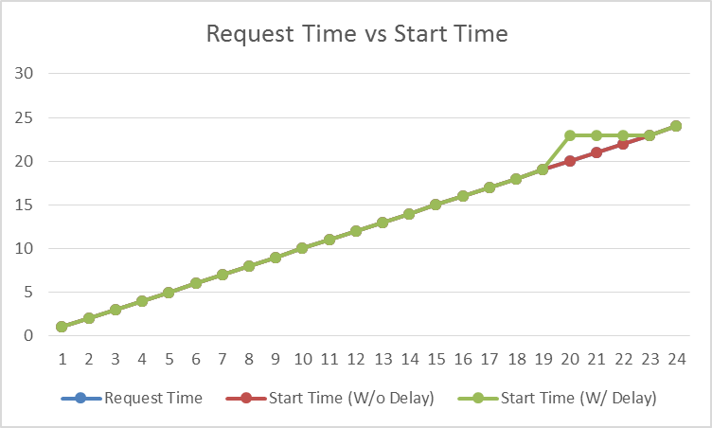

The Below Chart explains the benefit we get when we apply delay cost to time period approaching the non peak hours .The ideal time period to reschedule appliance would be for requests between 20th-22nd hour with a maximum delay of 3 hours.

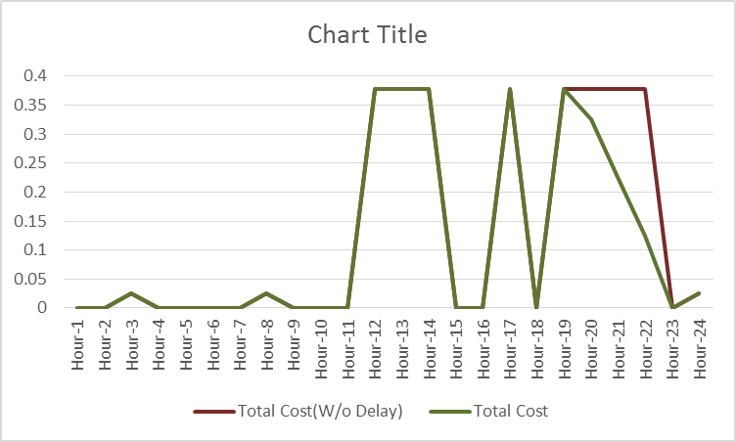

The Energy optimization study takes into account 15 households and 3 appliances in each household which does not need immediate power consumption when requested .So the 3 appliances considered for scheduling are dish washer , water heater and clothes dryer which can be scheduled in the off peak hours when prices are reduced .

We have worked on the range of possible outcomes and the probabilities they will occur for any choice of action The optimum results are based on various simulations carried out by generating various random scenarios of an appliance being on or off in a specific home

.